# Precision Agriculture in Virtual Reality Design Report

**Team:** Precision Agriculture in Virtual Reality 2

**Team Members:** Brad Whitesell, Chelsea Hogan, Joel Atwood

**Sponsor:** Dev Shrestha

## Table of Contents

Precision Agriculture in Virtual Reality Design Report 1

Table of Contents 2

Executive Summary 3

Background 3

Problem Definition 3

Expanded Deliverables 3

Project Plan 4

Team Roles and Responsibilities 4

Timeline Summary 5

Concepts Considered 6

Concept Selection 8

System Architecture 8

Design Evaluation and Future Work 9

Additional Information 12

## Executive Summary

The goal of the project is to create a virtual reality tool to be used in a classroom setting by which students can learn precision agriculture techniques and practices in a safe, cost effective and engaging learning environment.

## Background

The Palouse farming region is characterized as having rich, fertile soil and rolling hills. The geography of the Palouse presents a unique challenge to optimize effective cultivation and preservation of the region’s landscape. Precision Agriculture is a modern crop management concept that utilizes emerging technologies to optimize return on investment, while reducing the cost in seed, fertilizer, fuel and time. There is a need for an educational and promotional tool for showcasing and teaching practical applications of precision agriculture technologies. To address this problem, we are developing an immersive and realistic virtual reality experience that simulates the functionality of these technologies.

## Problem Definition

The team has been tasked with creating an immersive and realistic virtual reality experience that simulates the functionality of precision agriculture technologies. In addition, there should be an emphasis on producing an engaging environment for teaching practical applications of precision agriculture technologies.

Design goals included

* Auto pathing and GPS navigation
* Accurate height map terrain
* Pricing options
* Easy setup instructions

### Expanded Deliverables

For this project we have tasked with creating a virtual reality environment that replicates the Cook Farm. We have been provided with the Cook Farm elevation data for it to be translated into our application. The simulation is to provide the students with experience driving a tractor with an attached sprayer boom used to apply chemical to the field. The tractor is to be equipped with GPS location controls which can map where the spray has been applied to field. For classroom use, the simulation should have an autopilot or demonstration mode so that students can learn the optimal application techniques and pathing before practicing on their own. A data collecting tool should also be developed to provide students with feedback as to how their experience compared to the optimal application. The optimal application would have the greatest fuel and spray efficiency. The Virtual Reality Simulation will eventual be utilized by 4-6 classroom laboratory workstations. The hardware and software need to be able to be replicated and installed.

## Project Plan

### Team Roles and Responsibilities

Since our team was the second team to work on this project, we spent a great deal of effort in the first semester toward familiarizing ourselves with the project. As a team we met to review the project and meet with our sponsor to learn about precision farming and his vision for this project.

During the first semester we each individually set up our own machines with the current Unity application and each of us gained clearance to access lab which house the project workstation.

Brad set up a discord channel and forked the current repository for code storage and access. Joel updated the current project workstation.

During the first semester we divided our workload developing the current Unity Project. Brad was to work on visuals for fertilization data and develop data tracking for topsoil run off and crop yield. Joel set to work on developing a tractor console to help navigate and track statistics. Chelsea was to work on implementing field boundaries and work on tractor physics.

During the second semester our team continued to work on these objectives however the Unity Gaming Engine was difficult for us to navigate. Our team decided to look into other options for implementing our precision farming virtual reality simulator. After meeting with our sponsor, Joel was directed to research switching the application to using Farm Simulator 19 and Brad and Chelsea were to continue working on the Unity project.

After meeting with our sponsor, it was decided that our team would switch our focus to developing the new Farming Simulator 19 application. Immediately work began to create a map mod that replicated the GPS elevation data of the Cook Farm, create an auto path tool that can be used in developing several modes or scenarios and documentation needed for installation and execution of the current application.

In mid-October our team received confirmation from our sponsor that we would be switching to the Farm Simulator 19 application. Joel added this software as well as the VorpX VR mod to project workstation. Since it was toward the end of the semester and we were running short on time, we met with our sponsor to prioritize our objectives.

We reorganized our workloads to accommodate our change in software and sponsor set objectives. Brad immediately started work on importing the cook farm elevation data into our application. Joel researched existing mods that supplied an auto pathing tool that could later be used for our future features. Chelsea begin working on collecting and organizing the team’s communication, building the team portfolio, desktop start up instructions and wiki page.

### Timeline Summary

**January:** Project Assignment and Meet Team Members

**February:** Meet project Sponsor, Review Project Hand off Information, Apply to gain access to the lab.

**March:** Gain Access to the Lab. Learn about the Unity Game Engine, the C# programming Language, the Oculus Headset and Logitech Steering Wheel and Floor Pedals.

**April:** Set Project Directives, Set Up GitHub and Individual Work Stations, Learn about Farming Technologies from Dev.

**May:** Work on Course Work, Prepare for Summer Break.

**August:** Class Meetings, Regroup.

**September:** Reset Project Directives for the Semester. Distribute Work Load. Research Farming Simulator 19 and vorpX VR mod.

**October:** Farming Simulator 19 and vorpX VR 3d Driver are Approved, Purchased and Installed. Project Directives and Workload is Readjusted for Application Change.

**November:** Creation of Mapping Mod to Add Cook Farm. Auto-pathing Tool Added to Application. Documentation Creation for New Application.

**December:** Continued Documentation for Handoff, Snapshot and Course Deliverables.

### Concepts Considered

During the first semester our team focused on acquainting ourselves with the current simulation, the Unity Game Engine and the C# program language. The features our team, under the directive of our sponsor, choose to develop were establishing field boundaries, implementing crop yield and visualization and improving the tractor console navigation. We divided up the development areas and we each began to work on improving these features.

In the second semester each team member continued to work on their individual tasks utilizing their own workstation and the GitHub Repository. During research our team discovered a farming simulator application that had many of the features we were trying to implement into our current simulation.

Our team decided to take this information to our sponsor and it was decided that these new technologies warranted further research. Our team discovered that Farming Simulator 19 along with the vorpX Control mod would allow a user to drive a tractor and preform various farming activities in a virtual reality environment utilizing the Oculus Rift headset.

Our team was able purchase and Farming Simulator 19 and the vorpX VR 3D Driver and complete installation and calibration of the Logitech Steering Wheel and Floor Pedals and Oculus Rift Headset.

Upon further evaluation we took the following Pros/Cons itemization list to our sponsor:

**Pros for buying:**

* Farming Simulator works out of the box which means that it will be useful sooner.
* It supports VR
* More features already existing
* Everything should mimic reality more closely
* VR motion sickness settings have already been solved by the driver (probably)
* It isn't very expensive overall
* Development will be much faster and easier
* Easy to add new equipment

**Cons for buying:**

* We lose out the work from this semester and previous semesters
* Any changes we want from the game we have to mod as opposed to developing the game the way we want it
* It costs money

**Pros for making the game ourselves:**

* We have much more control of features and can customize it as we are building it
* May need maintained in future years as tractors update
* We do not need to rebuy a product if we want multiple machines (do note most of the cost will still come out of the VR equipment anyways)

**Cons for making the game ourselves:**

* It will probably take several semesters with multiple teams to get the game where we want it
* We as developers don't know how tractors work or how realistic we are programming things which requires constant input throughout development.
* Developing features like multiple tractor attachment options will take a lot of time
* There are issues with the current VR including the driver getting out of date which has already happened
* Will need maintaining
* As new students are added to the development, they will have to take time to orient and understand which will increase as the project grows.

## Concept Selection

Our sponsor approved the installation of Farming Simulator 19 and the vorpX VR 3d mod. Once installed and set up we met with our sponsor and he was able to test run the simulator. Our sponsor official approved the switch to the new application.

## System Architecture

Our system is a Virtual Reality Farming Simulation. The core design we wanted a user to interact with farming in a unique way that simulates driving a tractor as realistically as possible. We have an actor that is an avatar. This avatar can get into a tractor which can then attach attachments for actually farming. The field itself needs to have a method of feedback for the user to be able to see that they are farming properly. Additionally, we want to be able to load specific fields from real data of the farms in the Palouse area.

As I specified before we want this tractor farming to be extremely realistic. This project when finished will allow students to gain experience driving the tractor in the Palouse area. This can be costly to train in real life so our solution will reduce the time and cost.

This project was inherited from a previous semester. Their solution included Unity design and was able to be expanded upon. This had several flaws including VR that caused motion sickness in some users. Our group instead shifted to modding Farming Simulator 2019. This solution included specifically designed VR driver for our game. It also included many features to add realism that the Unity game didn’t have. We were also able to accomplish loading in a custom map that matches Cook Farms in the Palouse area. This map has hills which adds complexity to the training. Finally, we wanted to include some way to simulate the automatic driving that tractors use. Our design will include using a waypoint system and will be setup to be easily expanded.

## Design Evaluation and Future Work

Unfortunately, there is not enough time to complete the project. As it stands the project can be used in a BETA state. Future work on the project could include several things. One thing I would like to include is many extra niceties added to the map, such as a house and a few extra assets to give the game a polished look. The farm itself is still slightly jagged and needs smoothing in places. Additionally, Dev would like to include more visualization for the field including runoff and other field data. Dev also would like to improve the auto pathing setup to contain 4 different modes.

For the field, assume that user will have a similar map as one we provided you. For example, if a user has gw_2m map, for Guy Wicks field, which will have a similar format to ce-2m for Cook farm, the program should have a way to import that. So, it is going to be a file input. I am not quite sure what you meant in 1(b) but in addition to the field boundary, user may have waypoints for the tractor to follow. There are a few scenarios here, and I would like to have any of these options selectable.

**Option 1:**

The user has boundary map and planned path. For example, the user has the following field

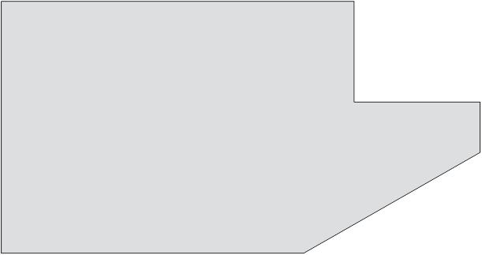

and the user plans to follow the path like this. The path is going to be a series of waypoints.

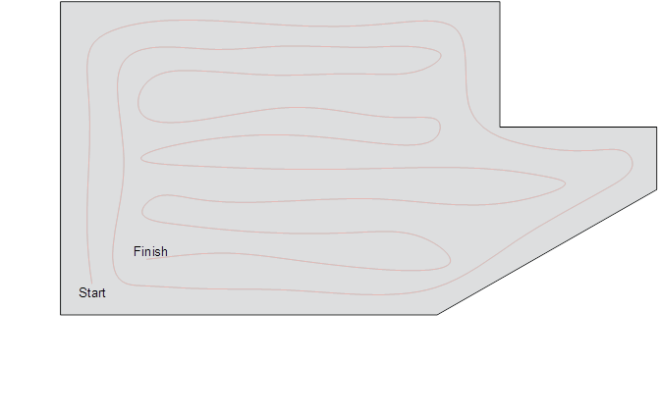

The VR system will show how much the actual tractor path is off from the planned path as user tries to drive following the planned path.

At the end of the run, the user will be able to see the results on how much overlap or skip was there. Along with the following information

1. The total path is driven
2. Total climbing up and down (two running total of positive and negative elevation along the path)
3. Percent of filed overlapped
4. Percent of filed skipped
5. Time to finish the job
6. Speed variation, a maximum and minimum speed of driving

**Option 2:**

Same as option 1. Instead of user driving, the tractor is in autopilot with certain restriction, they are

1. Change is direction cannot be more than 45° angle. (45 is default with option to override)
2. Speed cannot be more than 10 miles/h (10 is default with option to override)
3. Speed at corner must be reduced at the square root of curvature. For instance, if tractor is taking turn, like below

 must satisfy where C is a constant depending on unit. Put default value of 1 as default, but user should be able to override,

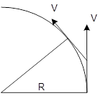

1. The path will have random offset of up to 4 inches on either side.

**Option 3:**

The user provides the field boundary, but the software optimizes the path to minimize one of the chosen parameters. Then the user drives the path

1. Minimize time taken to finish the job,
2. Total climbing up

The rest is the same as option 1

**Option 4:**

1. Same as option 3, but on autopilot with restriction on option2.

I think that next year the team could improve upon this with about a year. At that point the only cost would be getting more hardware and software.

## Additional Information

**Wiki Page:** <http://mindworks.shoutwiki.com/wiki/User:Hoga4447>

**GitHub Archive:** <https://github.com/palouse-agriculture-in-virtual-reality/FS-19-Cook-Farm-Mod>

* Most resources can be located within the Documentation directory of this repository.